METAL CLEANING
DE-RUSTING SERVICE
By YOUR COMPANY/INDIVIDUAL HERE

We de-rust and clean your metal parts for you using our safe, trademarked & tested
Rust Release product. Send your item to us and we will return them clean and rust free.
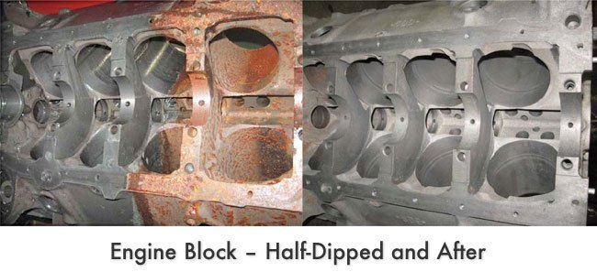
CLEAN YOUR:
- Engines
- Automotive calipers
- Motorcycle gas tanks
- Underbody/undercarriage
- Automotive panels/frames
- Clutches
- Brake shoes
- And, anything you have that’s metal …

What makes us different? We use a safe, acid-free product so your metal is protected from harsh chemicals.
- Great finish
- Economical
- Works fast

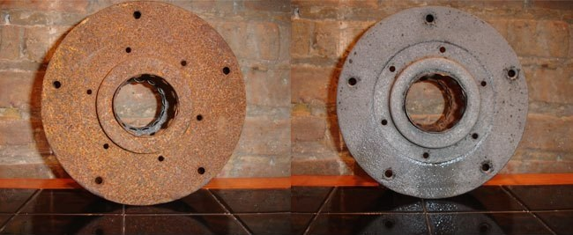

Send us an e-mail or photo of the items you need cleaned. Please let us know how many items you will be sending. We will send you a quote within 24 hours.

Please call with any questions or for a quote: (___) ___-____
Email: _______________@_______________.___

Visit https://www.rustrelease.com/ to view before and after photos and customer testimonials.

GREAT FINISH, SAFE ON YOUR METAL, ECONOMICAL

